ANALYSING THE PERFORMANCE AND EFFICIENCY OF THE RADISSON HOTELS USING VISUALIZATION TECHNIQUES

**1.INTRODUCTION**

1.1 OVERVIEW

The project title is Analysing the performance and efficiency of the Radisson Hotels using visualization techniques: The hotel industry is broad category of businesses that provides lodging services for travellers and tourists. Radisson owns multiple five star hotels across India. As a strategic move, the managing director of the Radisson wanted to incorporate Business and Data Intelligence in order to regain their market share and revenue.

1.2 PURPOSE

The purpose is to be the company of choice for guests, owners and talent. Whenever a guest plans a trip, or an invester or owner is thinking of a partner, or whenvever someone is looking for a career in the hospitality industry, they will all think of Radisson Hotels group first.

**2.PROBLEM DEFINITION AND DESIGN THINKING**

2.1 EMPATHY MAP

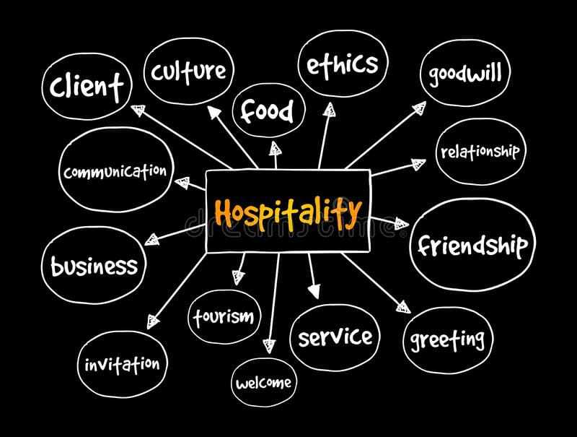

2.2 Ideation and brainstorming

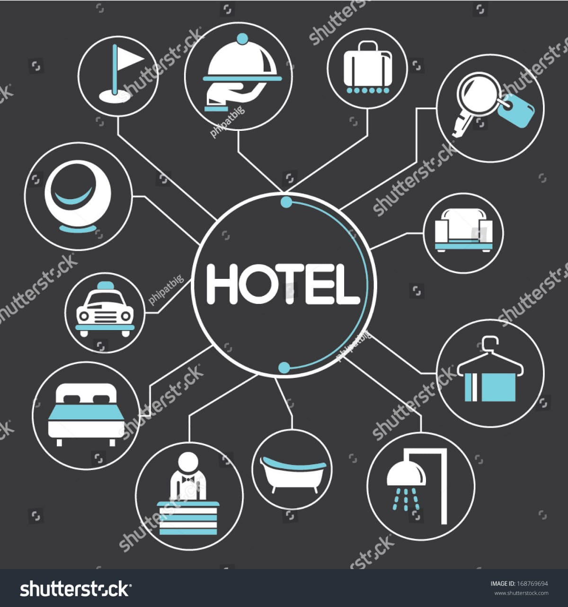

# 3. RESULTS

DASHBOARD

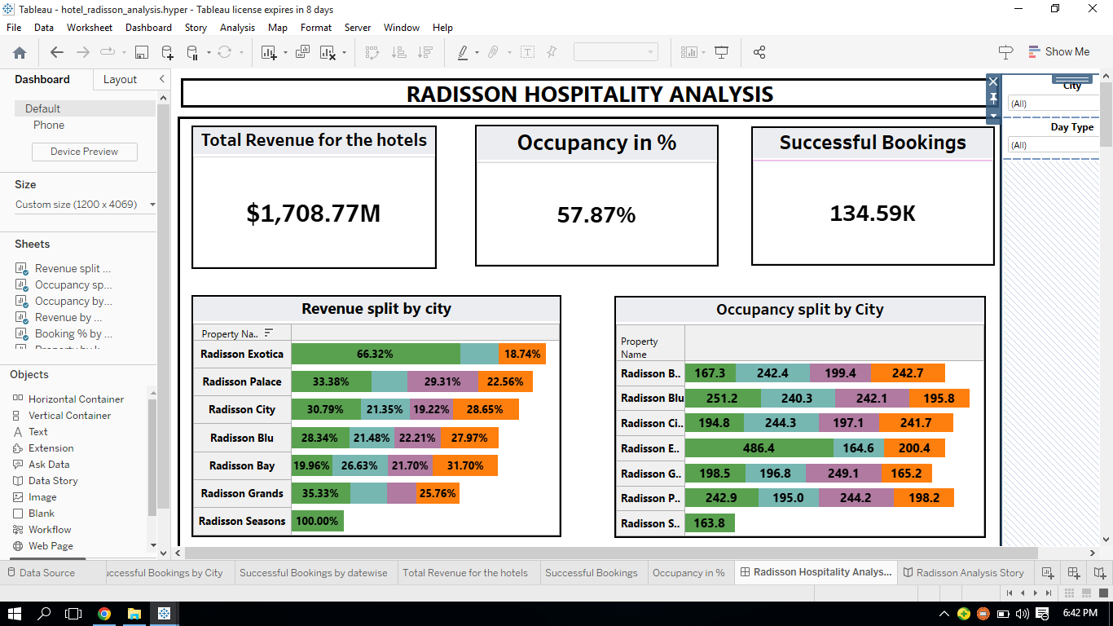

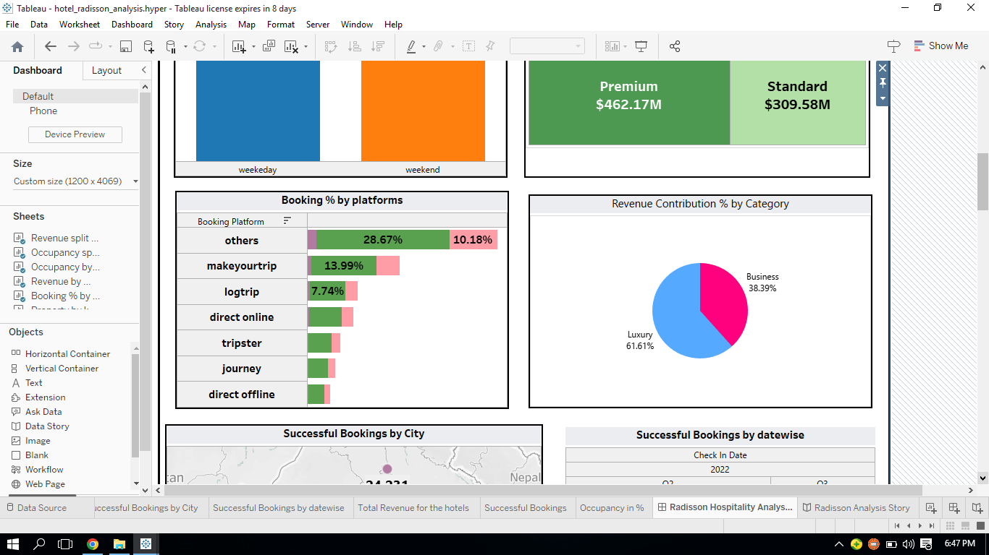

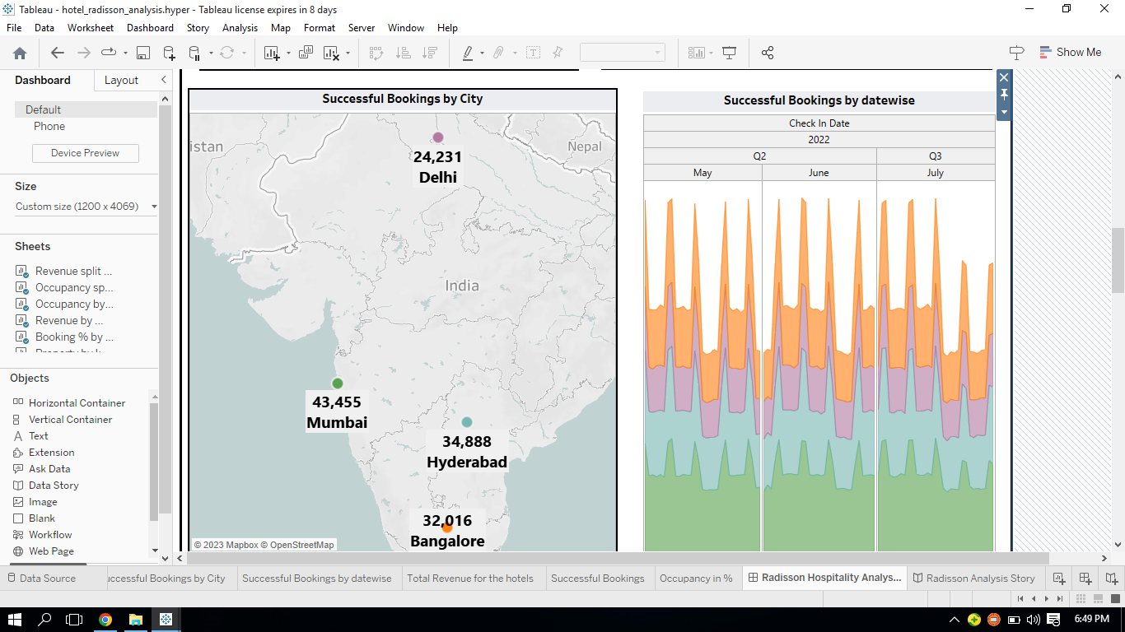

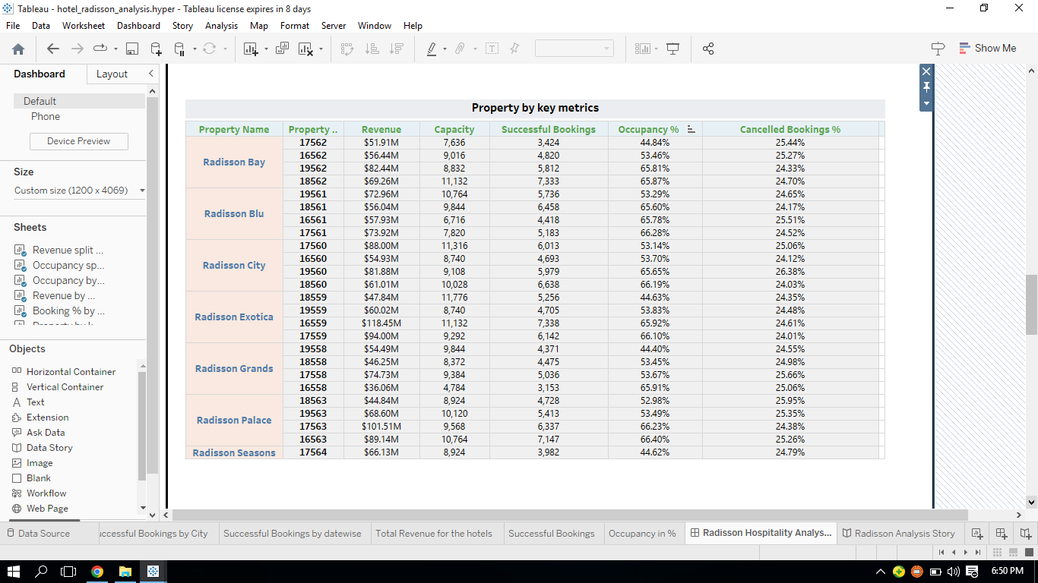

STORY

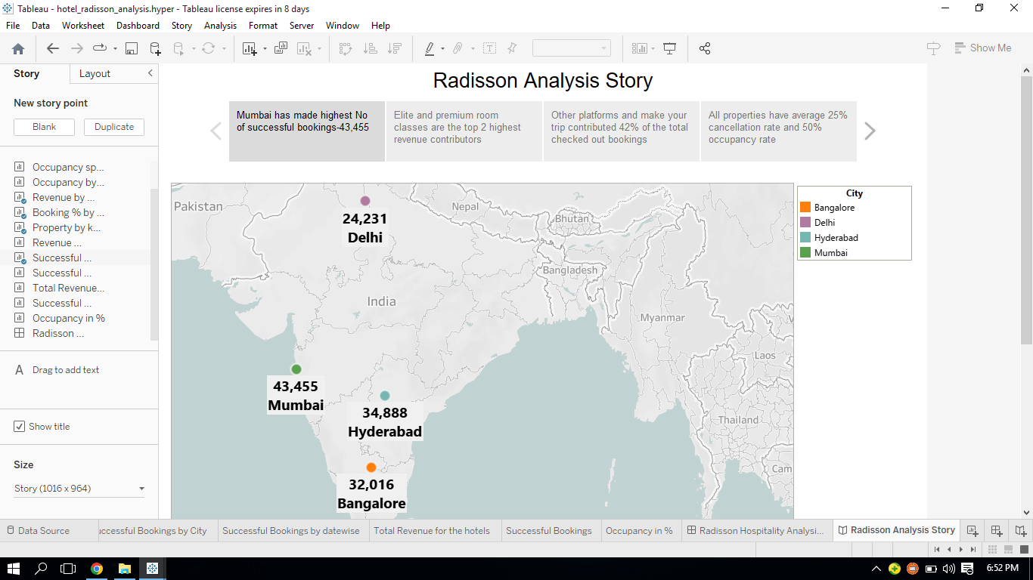

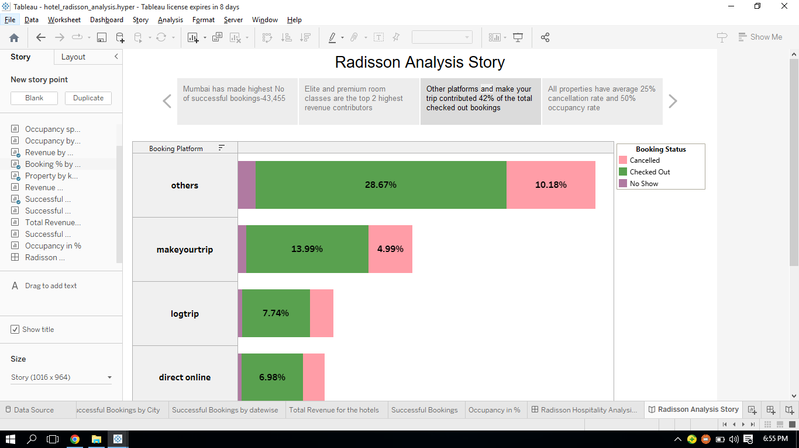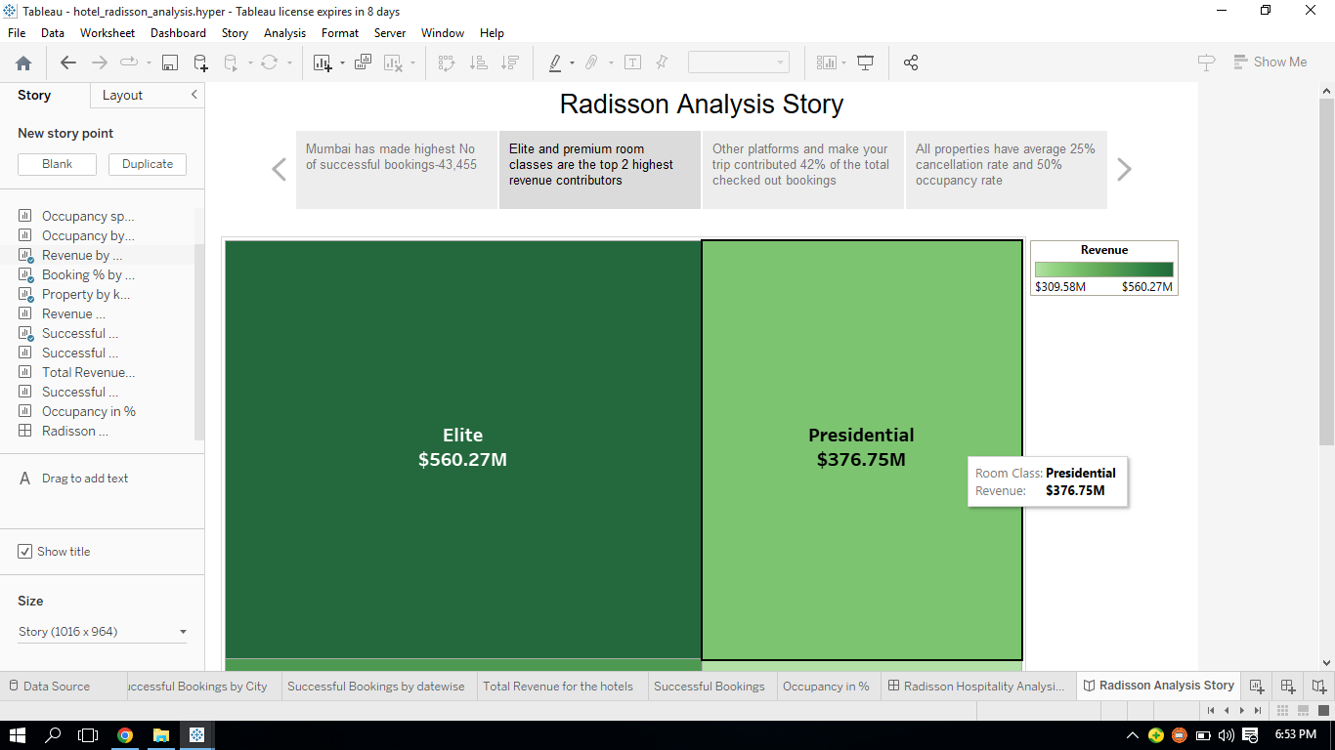

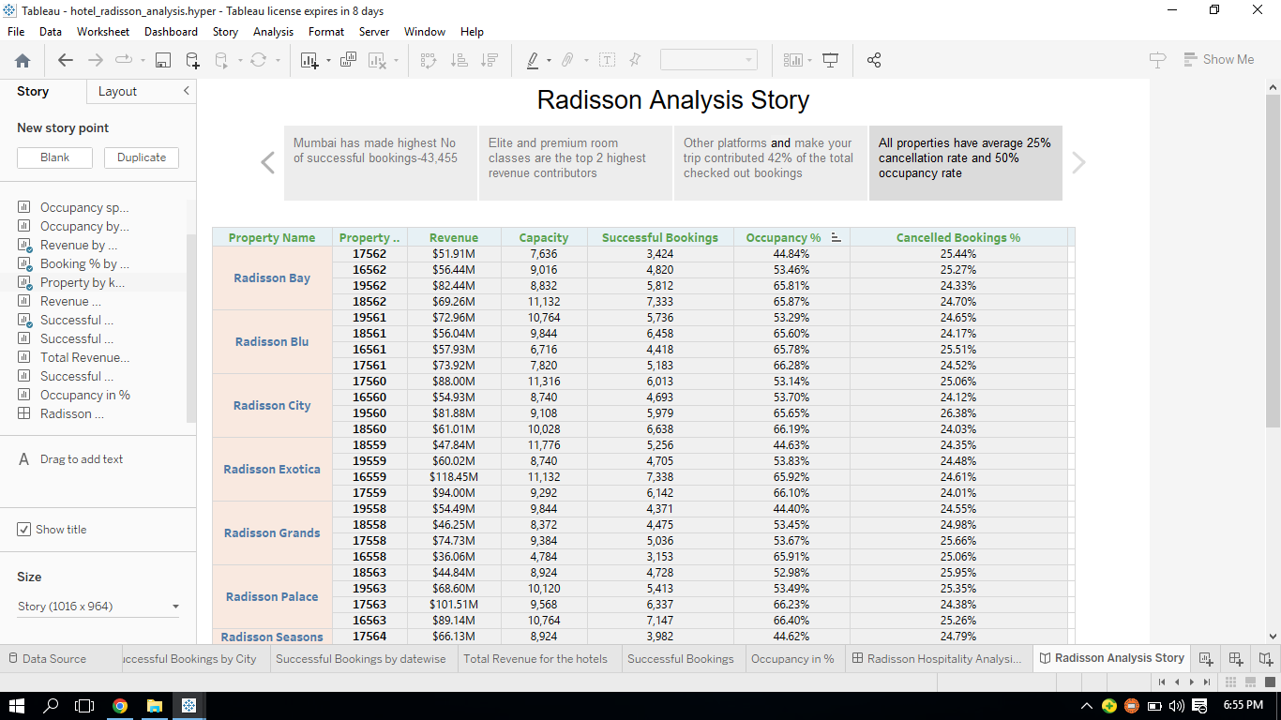

# 4. ADVANTAGES AND DISADVANTAGES

Advantages:

* Proper data analysis can allow the radisson hotel to build a tailored marketing strategy plan that is targetted to specific customer types and maximize revenue.
* This enables advertisers to build a more personalized user experience.
* They can identify key consumer groups and develop more content to serve their needs.

Disadvantages:

* Tableau does not provide the feature of automatic refreshing of the reprts with the help of scheduling.
* Current economic status is bound to take a toll on spending power.
* Still trying to establish itself in the emerging economies.

Application:

A unified customer experience. Many customers use multiple devices when browsing, booking and following up with hotels.

# 5. Conclusion:

The use of technology in the hospitality and tourism industry has helped speed up operations and helped the travelling process much more enjoyable and efficient. Technology not only helps large chain hotels, but can also be useful to B and B’s and other smaller companies in the industry.

# 6.Future scope:

The hospitality field covers the entire service industry that includes lodging, food and drink service, event planning, theme parks and transportation. It includes hotels, restaurants and bars.